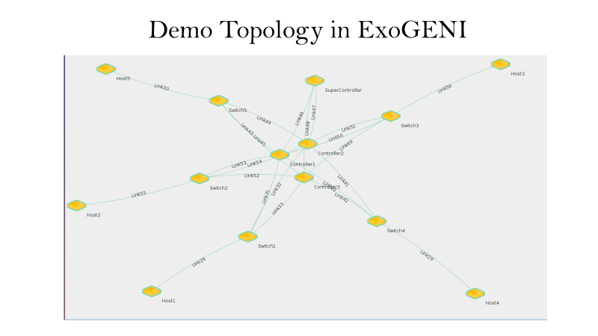

Demo Plan Setup

* 1 Supercontroller, 3 Controllers, 5 switches, 5 hosts
* H1 – connected to S1
* H2 – connected to S2
* H3 – connected to S3
* H4 – connected to S4
* H5 – connected to S5
* Ryu controllers
* 4 demo scenarios:
  + First 2 scenarios 🡪 Supercontroller inactive
  + Last 2 scenario 🡪 Supercontroller active